Department of Information Technology, Biotechnology and Science & Technology, Government of Karnataka

and

Karnataka State Council for Science and Technology

Press Note

Sir M. Visvesvaraya , Dr. Raja Ramanna , Sir C.V. Raman,

Prof. Satish Dhawan and Dr. Kalpana Chawla

Scientists and Engineers State Awards

for the Years 2013 and 2014

With a view to recognize and reward Scientific and Technological talent in the state, the Department Of Information Technology, Biotechnology and Science & Technology, Government of Karnataka has instituted several awards to the Scientists and Engineers of the State who have made significant contribution towards the development of the State in various fields of Science and Technology. These awards are being given every year since 1996.

The Government of Karnataka has constituted a high level committee under the Chairmanship of Prof. C.N.R. Rao to select eligible Scientists & Engineers for these awards. Karnataka State Council for Science and Technology (KSCST) has been entrusted with the responsibility of implementation of this programme.

Sir M. Visvesvaraya Award for Senior Scientists
Sir M. Visvesvaraya award to honor the senior scientists considering their lifetime contributions for the development of science and technology in the State. This award is being given to two senior scientists, every year. This award carries a cash prize of Rs.1,00,000 (Rupees One Lakh) a memento and a citation.

Dr. Raja Ramanna Award for Scientists / Engineers
Dr. Raja Ramanna award is given to a scientist / Engineer who has made a significant contribution in the field of History & Philosophy of Science / Science & Society / Science Education This award carries a cash prize of Rs. 75,000 (Rupees Seventy Five Thousand), a memento and a citation.

Sir C.V. Raman Award for Young Scientists
Sir C V Raman award carries a cash prize of Rs. 50,000 (Rupees Fifty Thousand), a memento and a citation. This award is given to scientists, below the age of 50 years, who have made outstanding achievements in the following fields
- Life Sciences
- Physical Sciences & Mathematics
- Chemical Sciences
- Agricultural Science and Animal Husbandry
- Medical Sciences

Prof. Satish Dhawan Award for Young Engineers
Prof. Satish Dhawan award carries a cash prize of Rs. 50,000 (Rupees Fifty Thousand), a memento and a citation. This award is given to Engineers, within 50 years of age, who have made outstanding achievements in Engineering and Technology

Dr. Kalpana Chawla Award for Young Women Scientists
Dr. Kalpana Chawla award is given to a woman scientist/engineer who has made outstanding work in her field for the development of science or technology in the state. This award carries a cash prize of Rs. 50,000 (Rupees Fifty Thousand), a memento and a citation.

During February 2015, the KSCST invited the nominations for the above State awards for the years 2013 and 2014.

The Karnataka State Council for Science & Technology is organising the awards presentation function on 30th December 2015 at 4.30 pm at J N Tata Auditorium, Indian Institute of Science, Bangalore on behalf of IT, BT & S&T Government of Karnataka.

Sri Siddaramaiah, Hon’ble Chief Minister of Karnataka and President, KSCST has kindly agreed to present the awards to the eminent Scientists and Engineers. Sri S R Patil, Hon’ble Minister for Information Technology, Biotechnology, Science & Technology and Planning & Statistics will preside over the function Bharath Ratna Prof. C N R Rao, FRS, National Research Professor and Linus Pauling Research Professor, Chairman, Vision Group on Science & Technology, Government of Karnataka will be the Chief Guest and Prof. Anurag Kumar, Director, Indian Institute of Science and Chairman, Executive Committee, KSCST will be the guest of honour. [visit www.kscst.org.in OR www.kscst.iisc.ernet.in for more information].

Recipients of Scientist and Engineer State Awards for the year 2013

Sir M. Visvesvaraya State Award for Senior Scientists for the year 2013
Field | Name and Address | Photo
Science and Technology | Dr. A. S. Kiran Kumar  Chairman, ISRO and Secretary,  Department of Space  Antariksh Bhavan, New BEL Road  Bangalore 560 231 | 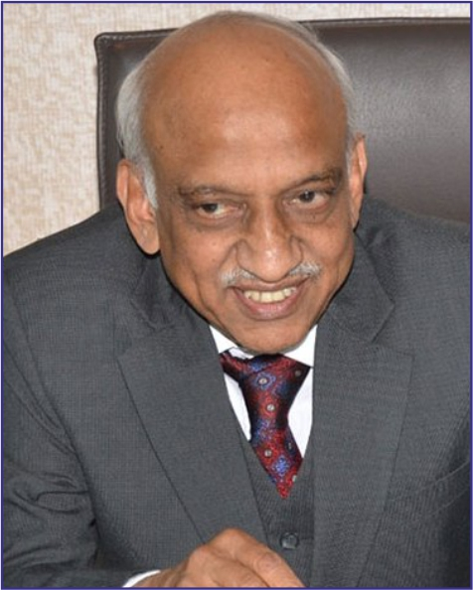
Science and Technology | Dr. Munivenkatappa Sanjappa  CSIR Emeritus Scientist and Formerly Director, Botanical Survey of India  Botanical Garden, University of Agricultural Sciences, GKVK, Bangalore – 560 065 | 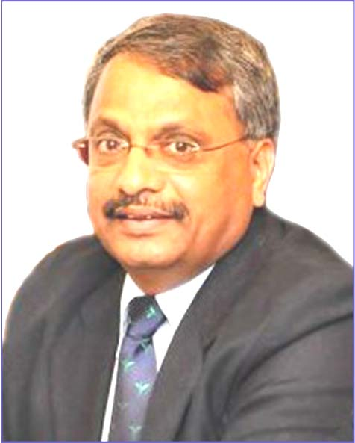

Dr. Raja Ramanna State Award for Scientists for the year 2013
Science Education | Prof. Kusal Kanti Das  Professor of Physiology  Department of Physiology,  Shri B.M.Patil Medical College,  BLDE University,  Vijayapur – 586 103 | 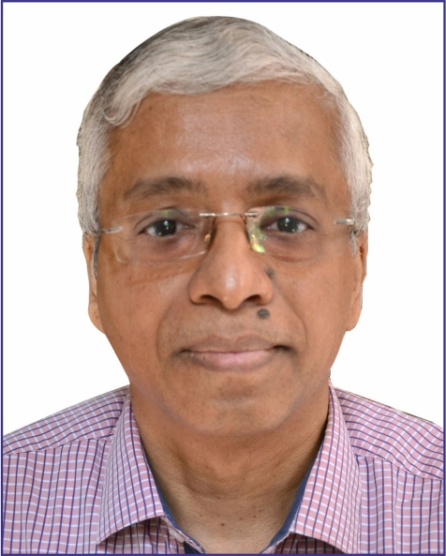

Sir C V Raman State Award Young Scientists for the year 2013
Physical Sciences & Mathematics | Dr. Basavaraj Angadi  Assistant Professor  Department of Physics  Bangalore University  Jnanabharathi, Bangalore - 560 056 | 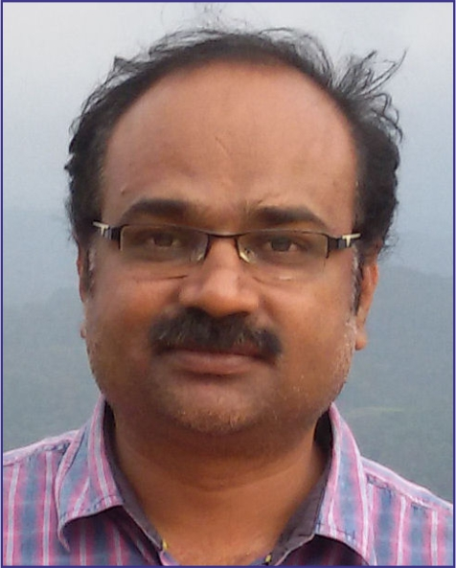
Chemical Sciences | Dr. K.S. Lokesh,  Associate Professor ,  Department of Chemistry  Vijayanagara Sri Krishnadevaraya University, Vinayakanagara, Cantonment, Bellary – 583 105 | 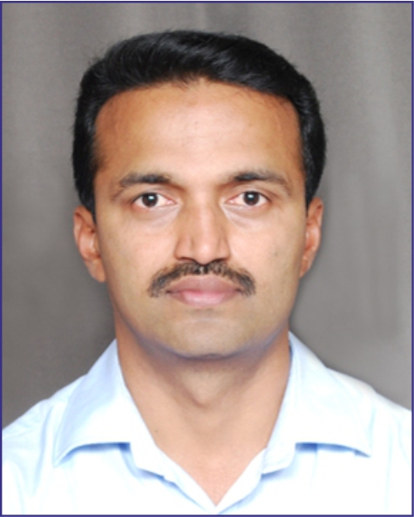
Medical Sciences | Dr. S. Chandrashekara,  Medical Director  Chanre Rheumatology & Immunology Centre & Research, #149, 15th main, NHCL, Water Tank Road, 4th Block, 3rd stage, Basaveshwaranagar, Bangalore – 560 079 | 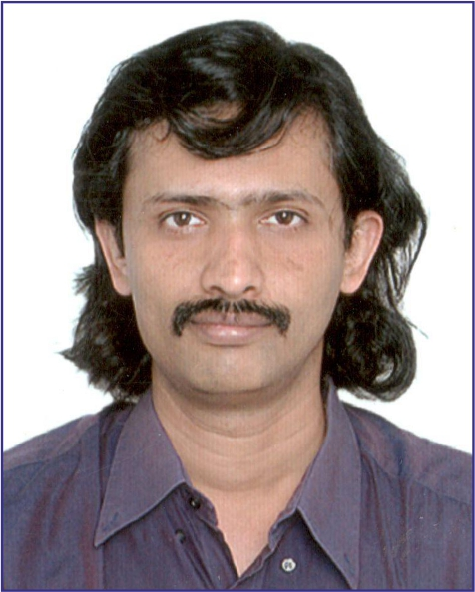
Life Sciences | Dr. H. C. Shreeharsha,  Faculty Scientist,  Institute of Bioinformatics,  ITPL, Whitefield,  Bangalore | 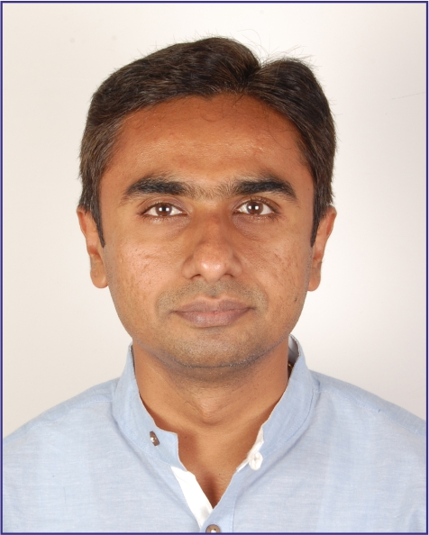
Agriculture Sciences & Animal Husbandry | Prof. Shamarao Jahagirdar,  Professor,  Dept of Plant Pathology,  University of Agricultural Sciences,  Dharwad – 580 005 | 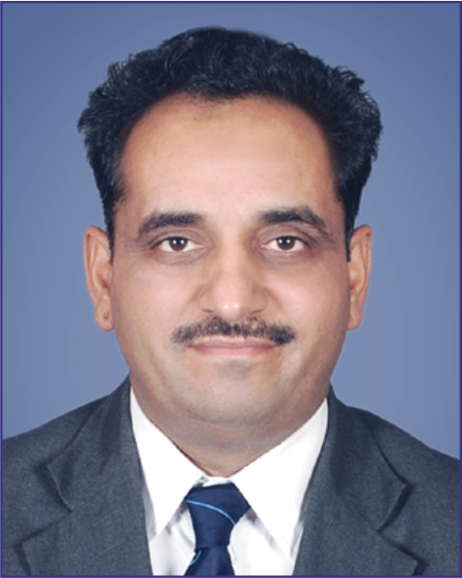
Prof. Satish Dhawan Award Young Engineers for the year 2013
Engineering Sciences | Prof. Shalabh Bhatnagar,  Department of Computer Science and Automation,  Indian Institute of Science,  Bangalore – 560 012 | 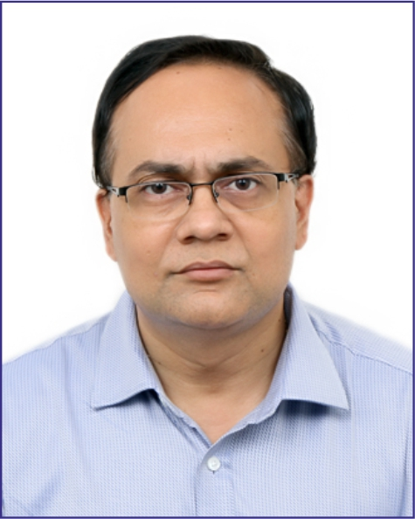
Engineering Sciences | Dr. Prasanta Kumar Panda  Materials Science Division,  CSIR-National Aerospace Laboratories,  P.B. No.1779, Vimanapura post,  Kodihalli,  Bangalore – 560 017 | 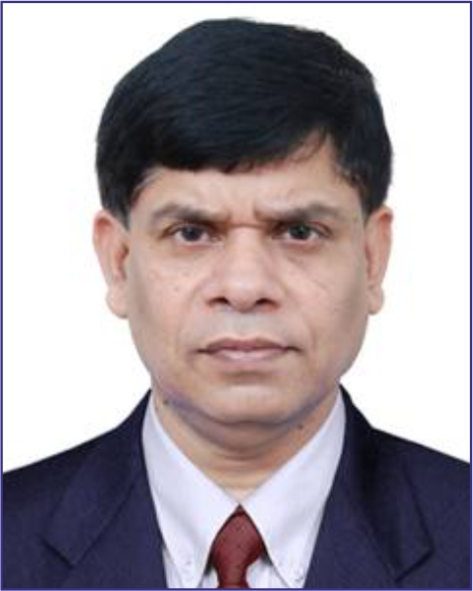
Engineering Sciences | Prof. G. S. Dwarakish  Professor & Head  Dept. of Applied Mechanics & Hydraulics,  NIT, Surathkal,  Mangalore | 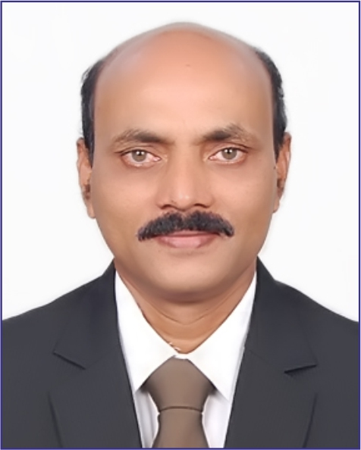
Engineering Sciences | Prof. K. R. Sreenivas  Engineering Mechanics Unit  Jawaharlal Nehru Centre for Advanced Scientific Research, Jakkur  Bangalore - 560 064 | 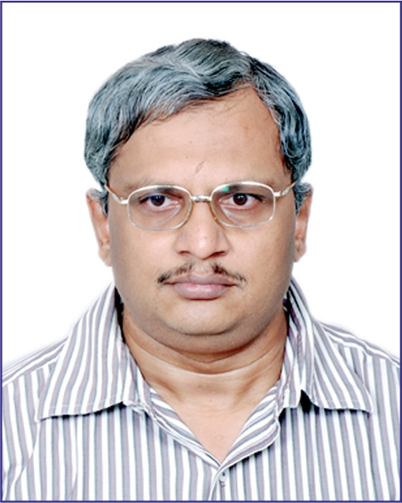

Dr. Kalpana Chawla Award for Women Scientists for the year 2013
Science and Technology | Dr. Veena Prasad  Centre for Nano and Soft Matter Sciences (CNSMS),  P.B. No: 1329, Jalahalli,  Bangalore - 560 013 | 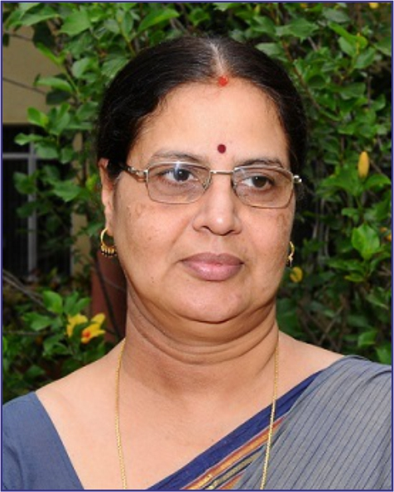
Science and Technology | Prof. B. Vishalakshi,  Professor and Chairperson,  Department of Chemistry  Mangalore University  Mangalagangothri-574 199 (DK) | 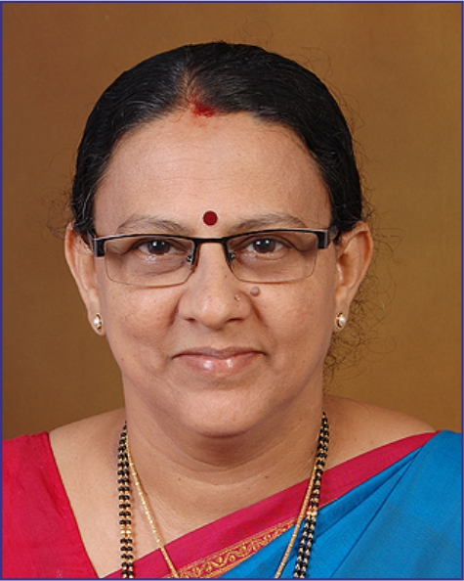
Recipients of Scientist and Engineer State Awards for the year 2014

Sir M. Visvesvaraya State Award for Senior Scientists for the year 2014
Science and Technology | Prof. Mathur R.N. Murthy  Molecular Biophysics Unit,  Indian Institute of Science,  Bangalore – 560 012, | 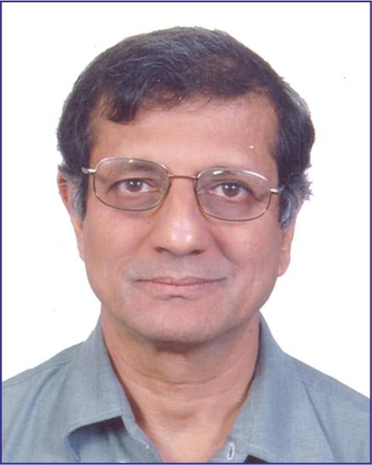
Science and Technology | Prof. Indrani Karunasagar  Director (R&D), Nitte University,  6th Floor, University Enclave,  Medical Sciences Complex, Deralakatte,  Mangalore – 575 028 | 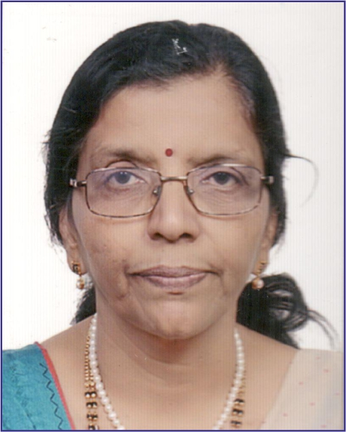

Dr. Raja Ramanna State Award for Scientists for the year 2014
History & Philosophy of Science / Science & Society/ Science Education | Prof. N. B. Ramachandra  Professor of Zoology (Genetics) &  Corodinator for M.Sc. Genetics,  Department of Studies in Zoology,  University of Mysore, Manasagangotri,  Mysore - 570 006 | 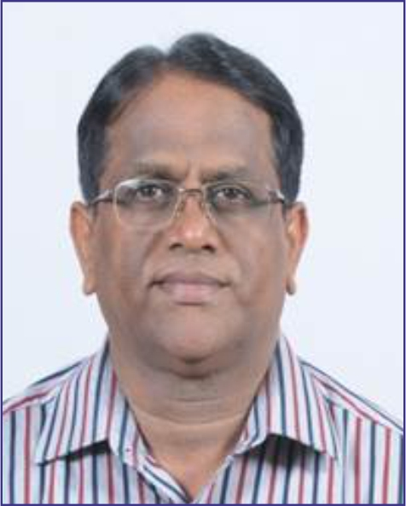

Sir C V Raman State Award Young Scientists for the years 2014
Physical Sciences & Mathematics | Prof. K.V. Prasad  Professor,  Department of Mathematics,  Vijayanger Shri Krishnadevaraya University,  Vinayaka Nagar,  Bellary - 593 104 | 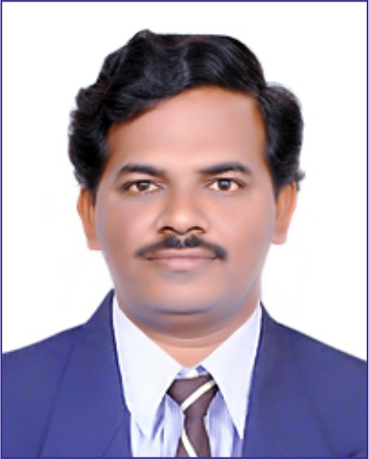
Chemical Sciences | Dr. T. Govindaraju  Associate Professor  Bio-organic Chemistry Laboratory  Jawaharlal Nehru Centre for Advanced Scientific Research (JNCASR)  Jakkur P.O., Bangalore 560 064 | 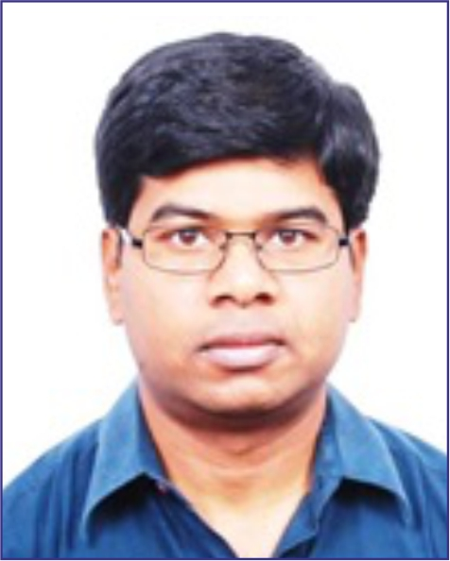
Medical Sciences | Prof. R. Kalyani,  Professor of Pathology  MVJ Medical College & Research Hospital, Hoskote, Bengalore District | 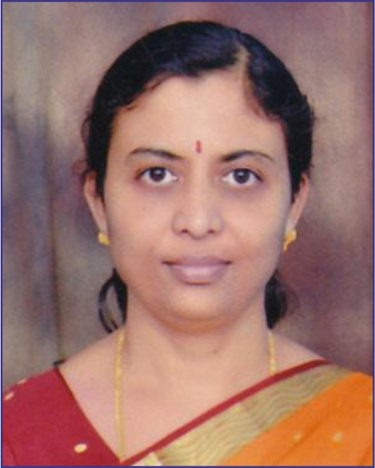
Life Sciences | Prof. Upendra Nongthomba,  Associate Professor,  Department of Molecular Reproduction, Development and Genetics,  Indian Institute of Science,  Bangalore -560 012 | 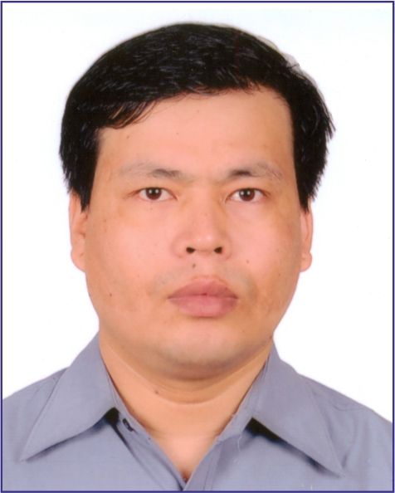
Agriculture Sciences & Animal Husbandry | Prof. Ramesh S. Bhat  Professor,  Department of Biotechnology  University of Agricultural Sciences Dharwad – 580 005 | 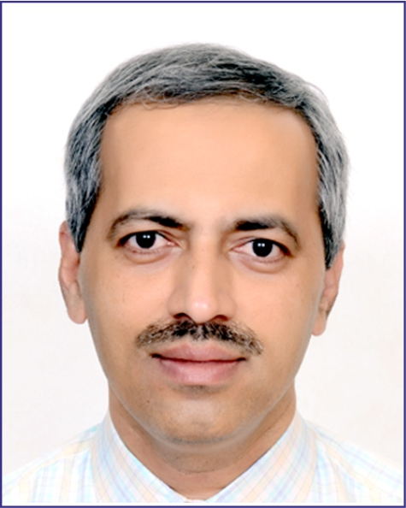

Prof. Satish Dhawan Award Young Engineers for the years 2014
Engineering Sciences | Dr. Latha Christie,  Associate Director  DRDO, Bangalore  Res: J 302, The Gardens Apartment,  Magadi Road, Bangalore – 560 023 | 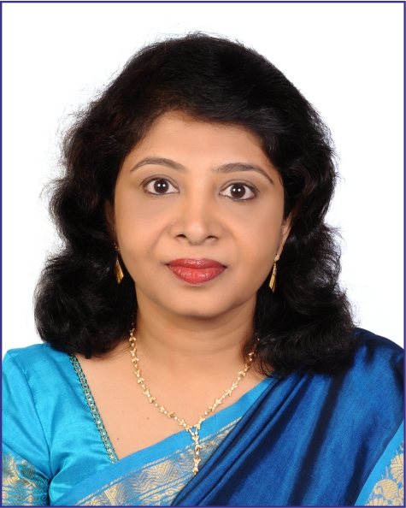
Engineering Sciences | Prof. Dinesh Rangappa  Professor and Chairman  Department of Nanotechnology  Visvesvaraya Technological University, Centre for Post Graduate Studies, VIAT, Muddenahalli,  Chikkaballapur – 562 101 | 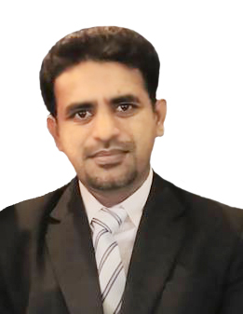
Engineering Sciences | Dr. G. Narayanan  Associate Professor  Department of Electrical engineering,  Indian Institute of Science  Bangalore – 560 012 | 